Coding Guidelines

Purpose of this Document
This document explains the coding standard that should be followed within projects.
Document Information

Submitted by Information
Name | Jinal Patel
Company Name | Aixtor Technologies
E-mail Address | jinal.patel@aixtor.com

Document History

Version | Date | Author | Description
0.1 | 8th Aprilʼ 2024 | Jinal Patel | Initial draft

Table of Contents
Contents
- Module Type 3
- Module Naming 3
- Package Naming 3
- Class Naming 4
- Defining Variables 4
- Code Level Commenting 4
- Coding Practice 4

Module Type
  - Web Module: A web module is a module which can be seen by guest user i.e. if module is created for end users then it be called as Web Module
  - Admin Module: An Admin module is a module which can be seen by admin user i.e. if module is available under control panel i.e. accessible by admin then it will be called as Admin Module.
  - Fragment/Overriding Functionalities Module: If a Module is created to override Liferay functionality then it will be called as Fragment/Overriding Functionalities Module.
  - Service Builder: A Module is called a service builder module if it has service.xml to generate DB tables i.e. provides layer to connect to DB tables.

Module Naming
  - Module name should have prefix as ax-hrms.
  - Name should always be in small letters.
  - There should not be any space in between module.
  - Web Module: should have -web as postfix.
  - Admin Module: should have -admin-web as postfix.
  - Fragment: should have -fragment as postfix.
  - Service Builder: Should have only functionality name.
Example: If we have a Requirement Called Contact us, then following will be created.
    - Web Module: ax-hrms-contact-us-web.
    - Admin Module: ax-hrms-contact-us-admin-web
    - Service Builder: ax-hrms-contact-us.
  - Note: Only 2 service builder module would be there in HRMS named ax-hrms-master and ax-hrms

Package Naming
  - Name should always be in small letters
  - Web Module: com.{projectname}.{functionality-name}. web
  - Admin Module: com.{projectname}.{functionality-name}.admin.web
  - Service Builder: com.{projectname}.{functionality-name}
Example: If we have a Requirement Called Leave then following will be created.
    - Web Module: com.ax.leave.web
    - Admin Module: com.ax.leave.admin
    - Service Builder: com.ax. hrms

Class Naming
  - Name should always start with a capital letter
Example: ax-hrms-leave-web Module can have RequestForLeaveAction, LeaveUtil, etc.

Defining Variables
  - Should always starts with small letter.
  - Defining variable is tedious but very important part, so all the variables used in a class/jsp/free marker/script should be meaningful.
  - Never use any numbers in variables like test1, employee2, session1, etc.
  - It should always be meaningful like if you are getting ThemeDisplay object then variable name could be themeDisplay.

Code Level Commenting
  - Class Level: Class level commenting should include following:
    - Purpose of the class i.e. usage, working etc.
    - Accessibility: The location, from where this class gets executed.
    - Author: Full name of the person who is creating the class.
  - Public Method Level: Public method level commenting should include following:
    - Purpose of the method, i.e. usage, working etc.
    - Parameters description.
    - Return type description.
  - Private Method Level: Private method level commenting should include following:
    - Purpose of the method i.e. usage, working etc.
    - Parameters description.
    - Return type description.

Coding Practice
  - Go to eclipse.ini file available in Eclipse home.
  - Add following property:
- -Duser={Your Full Name}
- -Duser.name={Your Full Name}
  - Start Eclipse.
  - Click on Windows → Preferences → Java → Code Style → Formatter

  - Make Active profile as Liferay [plug-in].
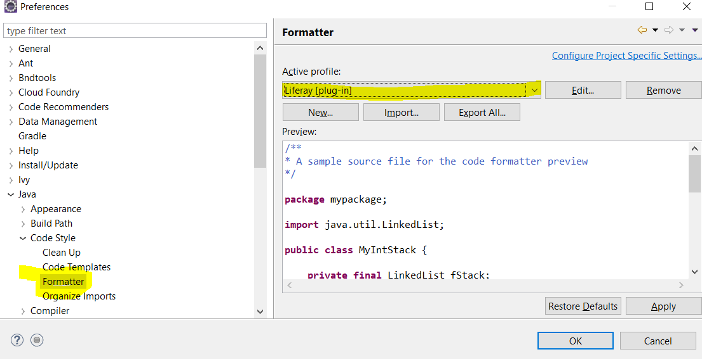
  - Once code is ready to be pushed please make sure:
- You donʼt have unused imports; unused imports can be removed by Ctrl + Shift + O
- Code can be formatted using Ctrl + Shift + F
o To generate commenting please press Alt + Shift + J
- All System.out.println should be removed.
- Use of logger in proper places.
- Code should have proper comments of what code is doing.
- Try to avoid more than 2 loops i.e. for loops.

